12.Design DFA using simulator to accept the input string “a” ,”ac”,and ”bac”.
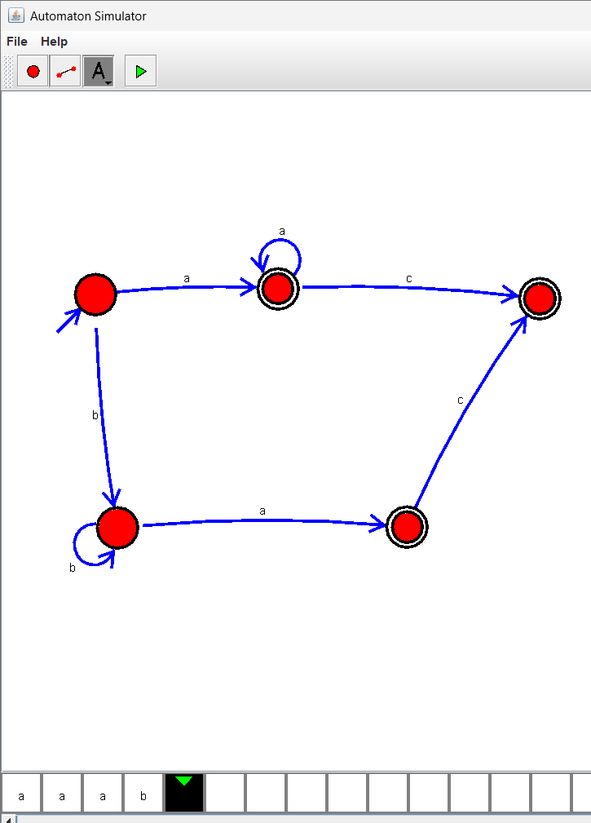
13.Design PDA using simulator to accept the input string aabb
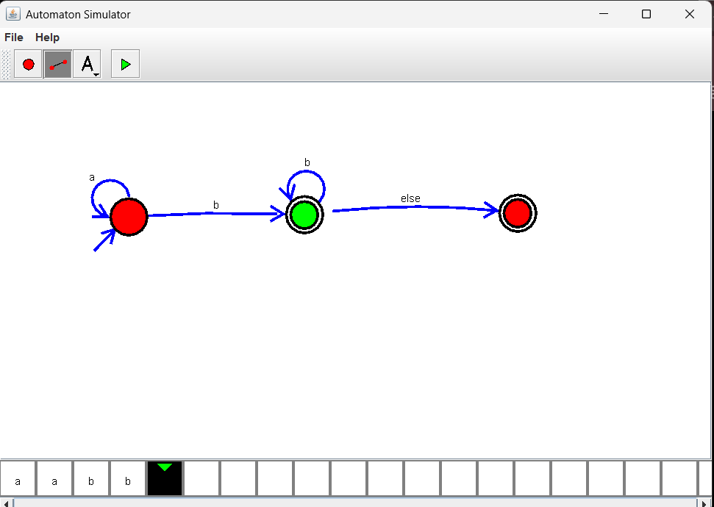

14.Design PDA using simulator to accept the input string anb2n

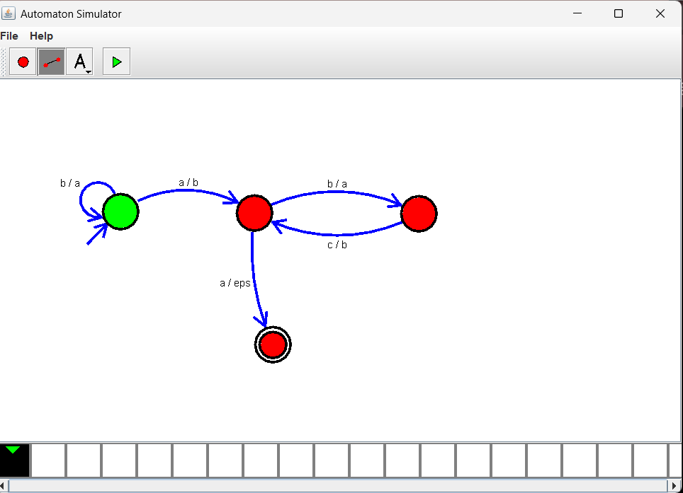

15.Design TM using simulator to accept the input string anbn
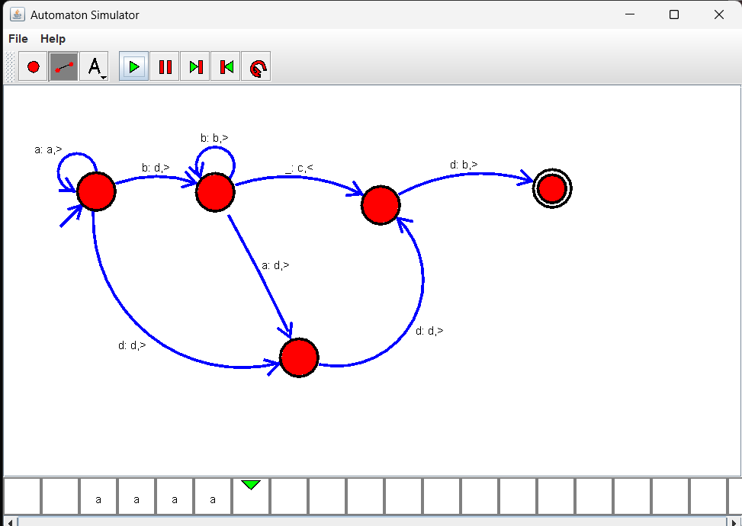

16.Design TM using simulator to accept the input string anb2n

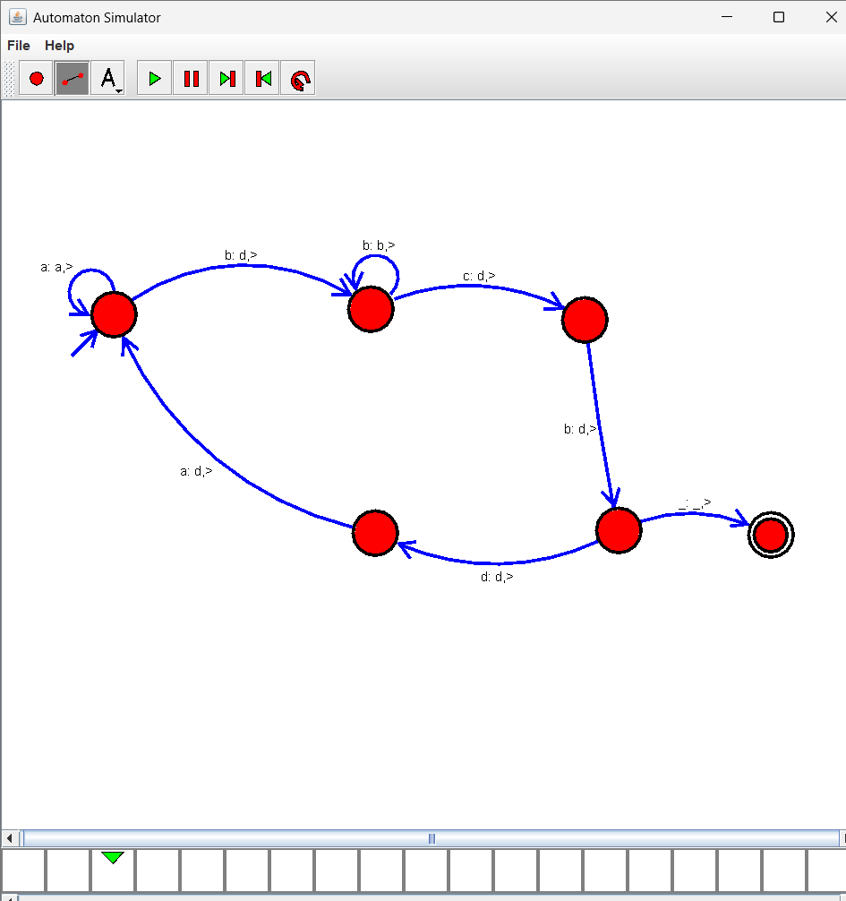
17.Design TM using simulator to accept the input string Palindrome ababa
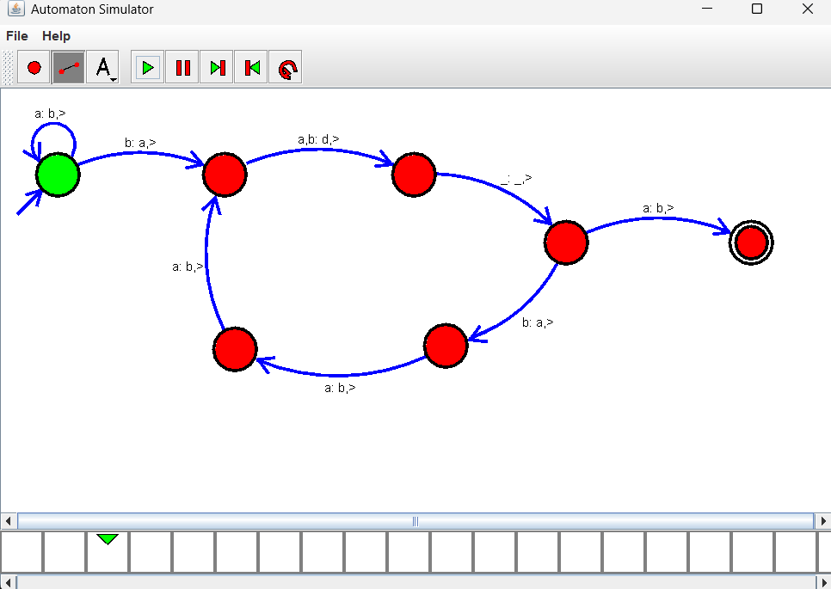

18.Design TM using simulator to accept the input string ww
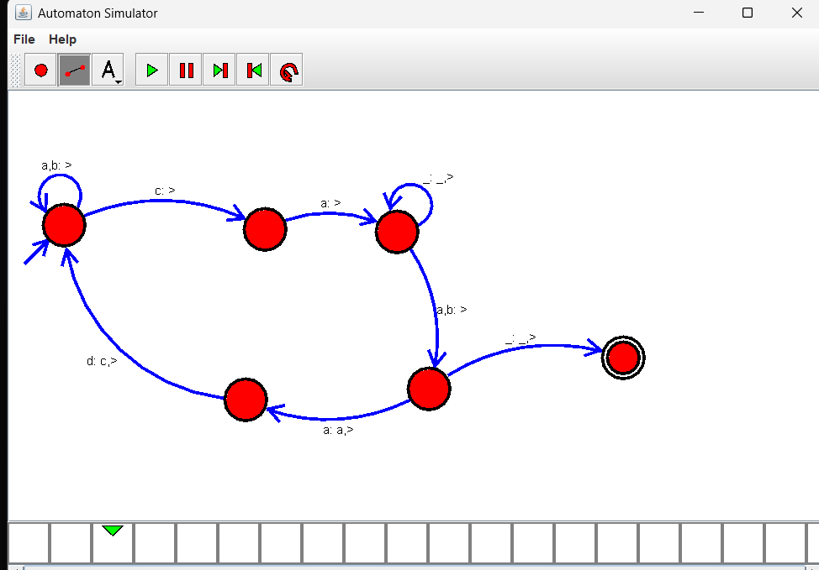

19.Design TM using simulator to perform addition of ‘aa’ and ‘aaa’
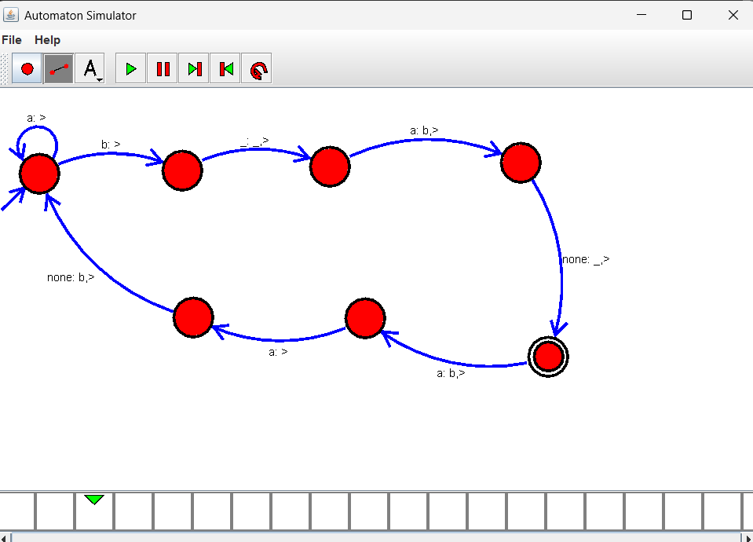

20.Design TM using simulator to perform subtraction of aaa-aa
